Laptops & Mobiles Sales Data Analysis Dashboard
Project Overview
This project presents an interactive Power BI dashboard developed to analyze Laptop and Mobile sales performance across different brands, regions, products, and time periods. The dashboard enables stakeholders to monitor KPIs, identify sales trends, compare regional performance, and make data-driven business decisions.
The project demonstrates skills in Power BI, Power Query, DAX, Data Modeling, Data Visualization, and Business Intelligence Reporting.

Objectives
- Analyze overall sales performance.
- Compare sales across different brands and regions.
- Monitor monthly sales trends.
- Identify top-performing brands.
- Track inventory movement using Stock Inward Days.
- Build an interactive dashboard for business stakeholders.

Tools & Technologies
- Power BI Desktop
- Power Query
- DAX (Data Analysis Expressions)
- Data Modeling (Star Schema)
- Microsoft Excel (Dataset)

Dataset
The dataset contains sales information for laptops and mobile phones, including:
- Product Category
- Brand
- Product Name
- Region
- Sales Date
- Quantity Sold
- Price
- Revenue
- Stock Inward Days
Note: This dataset is intended for educational and portfolio purposes.

Dashboard Features
KPI Cards
- Total Sales
- Quantity Sold
- Average Revenue
- Average Product Price
- Number of Brands
- Distinct Products
- Stock Inward Days

Interactive Filters (Slicers)
Users can filter the dashboard by:
- Year
- Product Category
- Brand

Visualizations
✔ Monthly Sales Trend
- Sales compared with previous period
- Monthly price trend
✔ Sales by Region
- Regional sales contribution
- Pie Chart
✔ Sales by Brand
- Top-performing brands
- Column Chart
✔ Geographic Analysis
- Regional sales distribution using Bing Maps

Key Insights
- Total Sales reached approximately 2 Billion.
- 96K products were sold.
- The business offers 20 different brands.
- Average Revenue per transaction is approximately 560K.
- Regional sales contribution is almost evenly distributed across all regions.
- Google, Nokia, Apple, Toshiba, and Redmi are among the highest-performing brands.
- Monthly sales remained relatively stable after May with minor fluctuations.

Business Recommendations
1. Focus on Best-Selling Brands
Increase inventory and promotional campaigns for top-performing brands.
2. Improve Underperforming Brands
Identify low-selling brands and introduce discounts or bundled offers.
3. Regional Marketing
Since regional sales are balanced, customize marketing campaigns based on customer preferences rather than geography alone.
4. Inventory Optimization
Monitor Stock Inward Days to reduce inventory holding costs and improve stock turnover.
5. Seasonal Sales Planning
Use monthly sales trends to forecast demand and prepare inventory before peak sales periods.

Dashboard Preview
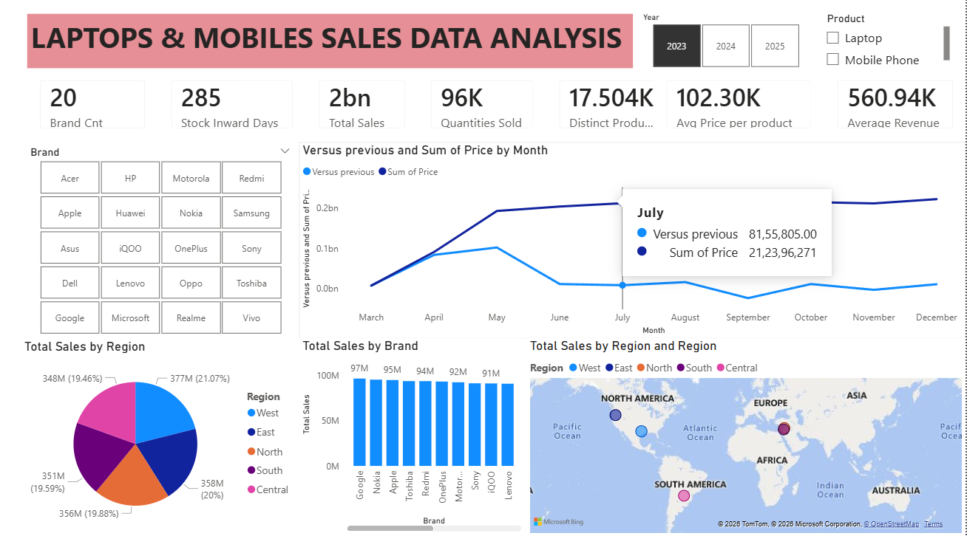

Project Structure
Laptops-Mobiles-Sales-Analysis/
│
├── Dataset/
│ ├── Mobile_Sales.xlsx
│
├── PowerBI/
│ ├── Laptops_Mobiles_Sales.pbix
│
└── README.md

Skills Demonstrated
- Data Cleaning
- Data Transformation
- Power Query
- Data Modeling
- DAX Measures
- KPI Development
- Dashboard Design
- Business Intelligence
- Data Visualization
- Trend Analysis
- Business Insights
- Interactive Reporting
Learning Outcomes
Through this project, I gained practical experience in:
- Designing interactive dashboards
- Building reusable DAX measures
- Creating calculated columns and measures
- Developing KPI reports
- Applying business analysis techniques
- Converting raw data into actionable insights

Future Enhancements
- Add Profit and Profit Margin analysis
- Customer segmentation dashboard
- Forecast future sales using Power BI Forecasting
- Drill-through pages for Brand and Region
- Mobile-optimized dashboard

